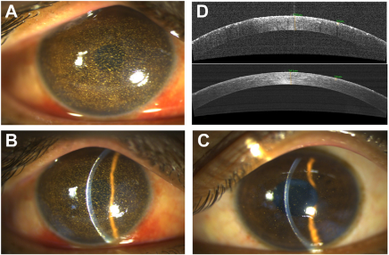

A 34-year-old goldsmith, with no comorbidity, presented with complaints of foreign body sensation and blurred vision in both eyes(more blurred in the right eye than the left eye) after sustaining an injury while working. Best corrected visual acuity was 6/18 in the righteye and 6/9 in the left eye. On examination, multiple gold foreign body particles were observed embedded in the cornea of both eyes (A,right eye; BeC, right and left slit photo, respectively). The corneal epithelium was intact with few punctate staining. Anterior-segment OCTrevealed hyperreflectivity in the epithelium and anterior stromal layer (D, right eye [upper panel] and left eye [lower panel]). the patient was managed conservatively with topical prednisolone acetate 1% four times daily (QID) and lubricatingeyedrops (carboxymethylycellulose 0.5% QID). The patient was symptomatically better on follow-up. Based on the provided images and clinical description please make an ophthalmic diagnosis for this patient. And output the diagnostic conclusions only.

**Corneal gold foreign bodies.**